E-commerce: Customer & Sales Behavior
Project Overview
Dataset: Online Retail dataset
Scenario: A mid-size online store wants to understand who its best customers are and which products drive revenue
Questions:
- Who are the top 10 customers by total spend?
- What % of revenue comes from the top 20% of customers (Pareto check)?
- What are the top 5 best-selling products by quantity and by revenue?
- Which month had the highest sales, and what likely drove it?
- What are the top 10 Country/Region by Total Orders and Revenue?
- Which products are frequently bought?
Deliverable: Power BI dashboard with revenue trend, top customers, top products, and a "VIP customer" recommendation.
Step 1 — Excel
The original dataset contained 1,048,575 transaction records. During the data cleaning process, 262,975 records with missing Customer IDs, 18,160 return/cancellation transactions (negative quantities), and 70 zero-priced transactions were removed. The final analytical dataset contains 767,370 valid sales transactions, which was used for all subsequent SQL analysis and Power BI dashboard development.

Cleaning Step |  | Records Removed
Original Records |  | 10,48,575
Missing Customer ID |  | 2,62,975
Returns/Cancellations Moved |  | 18,160
Price = 0 Removed |  | 70
Duplicate Records Removed |  | 34,150
Final Clean Dataset |  | 7,67,370
— SQL
Ran 6 queries to answer: who are the top customers, how concentrated is revenue (Pareto), what are the top products, what's the monthly trend, how does average order value vary by country, and what products are commonly bought together.
Key Findings
- Who are the top 10 customers by total spend?
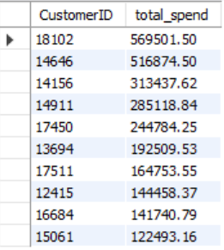
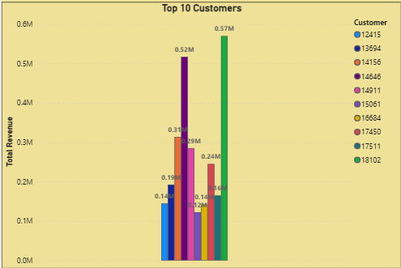

- What % of revenue comes from the top 20% of customers (Pareto check)?
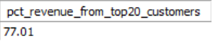
- What are the top 5 best-selling products by quantity and by revenue?
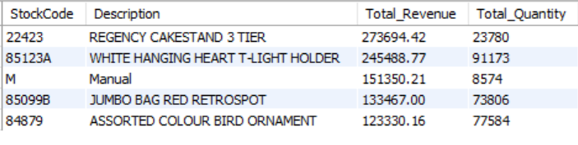
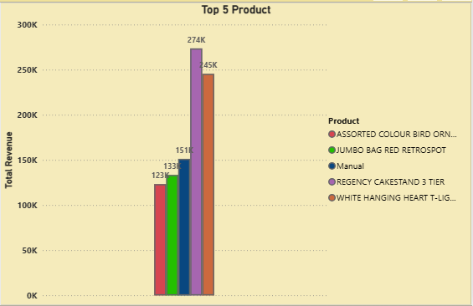
- Which month had the highest sales, and what likely drove it?
Order Month format is (Year-Month)
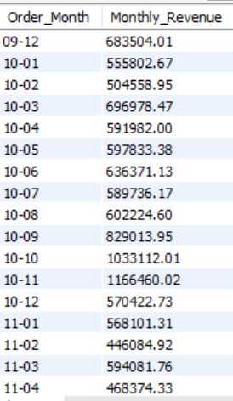
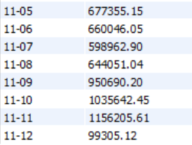
- What are the top 10 Country/Region by Total Orders and Revenue?
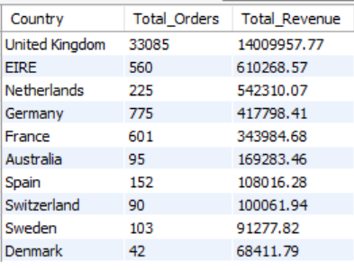
- Which products are frequently bought?
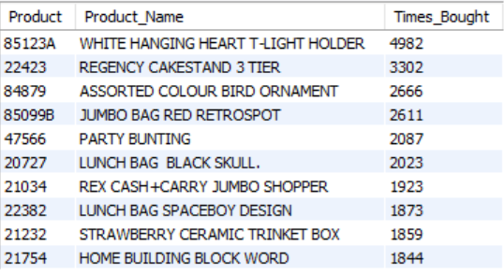

— KPI and Dashboard
: Power BI dashboard with revenue trend, top customers, top products, and a "VIP customer" recommendation.
